14.37: Neglecting the thickness of the wing (so that 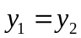in Eq. (14.17)), the pressure difference is 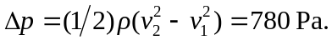The net upward force is then

